RedStarVibe: AI Search and Captions at Zero Cost
Nov 2, 2026 · @Ram Sahare

What we add
RedStarVibe gets meaning-based search and AI writing help using free local models, built on the Postgres, Redis and Celery it already runs. No Kafka, MongoDB or Typesense is needed.
Feature | What the user sees | Runs where | Priority
Keyword search (posts, people, hashtags) | Results while typing, typos forgiven | Postgres full-text + pg_trgm | 1
Semantic search | "goa ki shaam" finds "beach sunset" posts | pgvector + embedding model | 1
Hybrid ranking | Best of keyword and meaning in one list | FastAPI search service | 1
AI caption suggestions | 3 captions + hashtags appear after upload | Vision model on the ai queue | 2
Writing helper | "Improve" button rewrites the user's line | Small text model | 2
Tagline for text overlay | One short punch line to place on the photo or video | Same call as captions | 2
Hashtag suggestions | Hashtag chips from caption and image | Same call as captions | 2
Similar posts | "More like this" under a post | pgvector nearest neighbours | 3
Hindi, Hinglish, Tamil search | Any script finds the same post | Multilingual embeddings | 1
MCP search_posts tool | AI assistant can search posts | Reuses the search service | 3
Every AI feature is optional: if no model is running, search falls back to keyword only and the composer simply hides the suggestion chips, matching how the project already treats optional features.

How it fits RedStarVibe
Only one new service is added (Ollama). Indexing happens in the background on the existing ai queue, so search at request time only reads ready indexes.
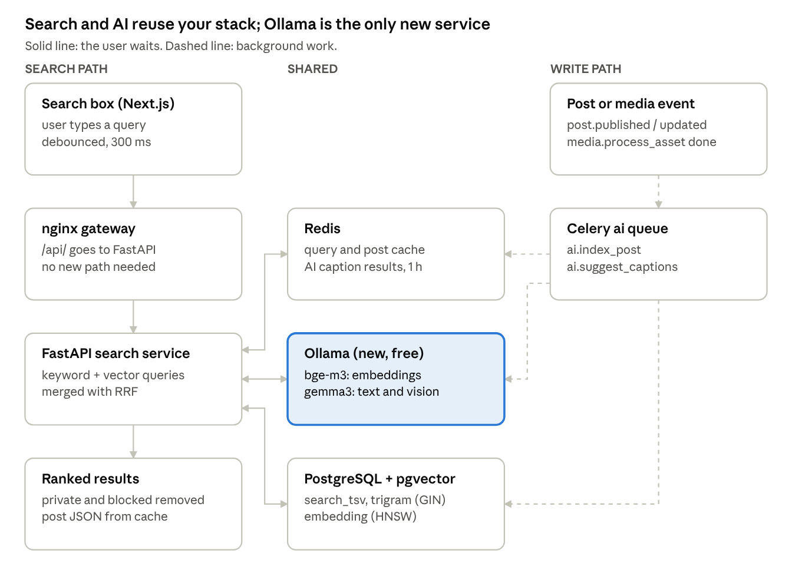
search path and write path · one new service
On the left, a search touches Redis, Ollama (one small embedding of the query) and Postgres, then returns. On the right, every new or edited post and every processed photo is indexed and captioned in the background; the composer reads caption suggestions from Redis.

Free AI models and levels
All models below are open and run in Ollama on your own server, so there is no per-call cost. Pick the level your server's RAM allows; you can start at Level 0 and move up without code changes.
Model (Ollama name) | Job | Approx. RAM | Notes
bge-m3 | Embeddings for search, 1024 numbers per post | about 1.5 GB | Multilingual: Hindi, Tamil, Hinglish, English land close together
multilingual-e5-small (via sentence-transformers) | Lighter embeddings, 384 numbers | about 0.5 GB | For small servers; slightly weaker results
gemma3:1b | Writing helper, hashtag ideas from text | about 1.5 GB | Text only, fast on CPU
gemma3:4b | Captions and tagline from the photo | about 4 to 5 GB | Reads images; slow on CPU (tens of seconds), so it runs in the background
RAM figures are rough for 4-bit models; check with docker stats after the first run.

Levels by server size
Level | What works | Extra RAM | Good for
0. No AI | Keyword search, hashtag and user search with typo tolerance | none | Any server, day one
1. Search AI | Level 0 + semantic and hybrid search, similar posts | about 1.5 GB | 4 GB server
2. Text AI | Level 1 + writing helper, hashtag ideas | about 3 GB | 8 GB server
3. Full AI | Level 2 + captions and tagline from the photo | about 7 to 8 GB | 12 GB or more
The existing Claude client (app/ai/llm_client.py) stays as an option. A new AI_PROVIDER setting chooses ollama, anthropic or none.

Backend implementation
Everything follows the existing pattern: a new search module, new tasks on the ai queue, handlers in the single event dispatcher, and one migration.

1. Infrastructure
- Postgres image: switch to one that ships pgvector (for example pgvector/pgvector:pg16, matching your current major version).
- Add an ollama service to infra/docker/docker-compose.yml on the internal network only, with a volume for models. Put it under a compose profile ai so it starts only when wanted.
- No new nginx path: all calls go through /api/.

2. Migration (next number in migrations/versions)
CREATE EXTENSION IF NOT EXISTS vector;
CREATE EXTENSION IF NOT EXISTS pg_trgm;
ALTER TABLE posts
ADD COLUMN search_text text,
ADD COLUMN search_tsv tsvector,
ADD COLUMN embedding vector(1024),
ADD COLUMN embedding_model text,
ADD COLUMN indexed_at timestamptz;
CREATE INDEX posts_search_tsv_idx ON posts USING gin (search_tsv);
CREATE INDEX posts_embedding_idx ON posts USING hnsw (embedding vector_cosine_ops);
CREATE INDEX users_username_trgm_idx ON users USING gin (username gin_trgm_ops);
CREATE INDEX hashtags_name_trgm_idx ON hashtags USING gin (name gin_trgm_ops);
Use the simple text search config, because Postgres has no Hindi stemmer and simple treats every script the same. If a hashtags table does not exist yet, add it in this migration. Change vector(1024) to vector(384) if you choose the small model.

3. AI client
- New app/ai/local_client.py: calls Ollama over HTTP with httpx, short timeouts, returns None on failure.
- New app/ai/embeddings.py: embed(text) -> list[float] | None and EMBEDDING_MODEL name.
- New settings in app/core/config.py: AI_PROVIDER, OLLAMA_URL, EMBED_MODEL, CAPTION_MODEL, TEXT_MODEL. Defaults keep AI off.

4. Indexing on publish (background)
- A post publishes; the service already emits post.published.
- In app/workers/event_tasks.py, the dispatcher enqueues ai.index_post(post_id) on the ai queue (also on post.updated).
- The task builds search_text from Post.full_text (caption plus overlay text, as CLAUDE.md requires) and hashtags.
- It sets search_tsv = to_tsvector('simple', search_text); this works even with AI off.
- If embeddings are on, it stores the vector and embedding_model, then sets indexed_at.
Send the vector as a text literal ('[0.12,-0.48,...]'::vector) instead of registering a custom asyncpg type, so it stays safe under PgBouncer transaction mode (ADR 0002).

5. Backfill and model changes
A beat task (nightly) picks posts where indexed_at is null or embedding_model differs from the current one, in batches of 200, and enqueues ai.index_post. The same task re-indexes everything after a model switch.

6. Caption, tagline and hashtag suggestions
- When media.process_asset finishes an image, it enqueues ai.suggest_captions(media_id) on the ai queue.
- The task sends the small 480 px WebP variant to gemma3:4b with a prompt that must return JSON: 3 captions, 1 short tagline, up to 8 hashtags, in the user's language.
- The result is stored in Redis at ai:captions:{media_id} for 1 hour.
- GET /api/v1/ai/captions/{media_id} returns it, or {status: "pending"}. For video, use a frame from the poster image.
The user is never blocked: they can post before suggestions arrive. Normal moderation still runs on the final post.

7. Writing helper
POST /api/v1/ai/rewrite with the user's text and a style (fun, short, Hinglish). Runs gemma3:1b with a 10 second timeout. Triggered by a button, not on every key press. Rate limit per user in Redis (for example 20 per hour) so one user cannot block the CPU.

8. Search API
Endpoint | Returns
GET /api/v1/search?q=&type=posts | Ranked posts, cursor paginated
GET /api/v1/search?q=&type=users | Users by trigram similarity
GET /api/v1/search?q=&type=tags | Hashtags with post counts
GET /api/v1/search/suggest?q= | Top 5 users and tags for the search box
GET /api/v1/posts/{id}/similar | Nearest posts by vector
Wire the module the usual way: router in app/api/v1/router.py, models in app/models.py, task file in celery_app.py include, then make types.

9. MCP tool
Add search_posts(query, limit) to app/mcp/server.py. It calls the same search service, so privacy rules are applied once.

Search ranking and rules
Run the keyword query and the vector query side by side, take the top 50 of each, and merge them with Reciprocal Rank Fusion. A post near the top of either list rises; a post high in both wins.
\text{score}(p) = \sum_{\text{list}} \frac{1}{60 + \text{rank}_{\text{list}}(p)} \; + \; w \cdot \text{freshness}(p)
Start with a small freshness weight w (for example 0.002 per day newer) and tune it with real queries.

Rules every query must follow
- Skip deleted and unpublished posts, test-batch posts if you hide them, and posts from private accounts the viewer does not follow.
- Skip authors the viewer blocked or who blocked the viewer.
- With AI off or the model down, return keyword results only; never return an error for that.
- Normalize the query: trim, lowercase, strip # and @, limit to 100 characters.
- Rate limit search per IP and per user in Redis.

Cache
Key | Holds | TTL
search:q:{hash of normalized query} | Embedding of the query | 1 day
search:res:{hash}:{page} | Public result IDs only (no private posts) | 60 seconds
Existing post JSON cache | Post bodies for hydration | as today
Private-account results are filtered after the cache read, per viewer, so the shared cache never leaks them.

Frontend
All new UI uses the existing hand-written primitives and calls only /api/, so the strict CSP needs no change.
Where | What to build | Behaviour
Composer, after upload | "AI suggestions" row of caption chips and hashtag chips | Polls /ai/captions/{media_id} every 3 s for up to 60 s; tap a chip to insert; hidden if AI is off
Composer, caption box | "Improve" button with style picker (Fun, Short, Hinglish) | Shows the rewrite as a preview; user accepts or ignores
Media editor | "Use AI tagline" chip | Fills TextOverlay text; user still drags and resizes it as today
Header | Search box with suggestions | 300 ms debounce; shows top people and tags
/search page | Tabs: Posts, People, Tags | Grid of posts with <picture> variants; infinite scroll on the cursor
Post page | "More like this" row | From /posts/{id}/similar; hidden when empty
After backend schema changes, run make types and alias the new types in src/lib/api/types.ts. Add Playwright checks at 360, 768 and 1280 px for the search page and the suggestion chips.

Zero-cost hosting options
The best free setup is an Oracle Always Free ARM server running your Docker stack at AI Level 2, with Cloudflare Tunnel in front. Oracle cut the free ARM limit to 2 OCPUs and 12 GB RAM from June 15, 2026 (InfoQ), so the full vision model is tight there.
Option | Monthly cost | AI level that fits | Good | Watch out
A. Oracle Always Free ARM + Cloudflare Tunnel | 0 | Level 2 (Level 3 is tight) | Always on, public, 12 GB RAM | ARM build of every image; free accounts can be stopped if over limits; sign-up needs a card for verification
B. Your own PC or laptop + Cloudflare Tunnel | 0 (electricity only) | Up to Level 3 if you have 16 GB RAM | Easiest, uses make up as today | Site is down when the PC is off; home upload speed limits video
C. Hybrid: Oracle server + Cloudflare Workers AI for embeddings | 0 within free allowance | Level 1 on Oracle + cloud embeddings | Saves about 1.5 GB RAM on the server | Data leaves your server; 10,000 free Neurons per day (Cloudflare); bge-m3 costs 1,075 Neurons per million tokens
D. Old PC or mini PC at home + Cloudflare Tunnel | 0 monthly (one-time hardware) | Level 3 | Always on, more RAM than free cloud | Power cuts; buy once

Pieces that are free in every option
- Cloudflare Tunnel: the cloudflared container connects out to Cloudflare, so no open ports and your IP stays hidden. Add it as one more service in compose pointing at the gateway.
- Cloudflare DNS + SSL: free with any domain added to Cloudflare.
- Cloudflare R2: your project already supports it for media (ADR 0005); it has a free monthly storage allowance. Local SeaweedFS also works and costs nothing.
- Domain: for testing, a temporary trycloudflare.com link from a quick tunnel is free. For a stable public site, a cheap .in or .xyz domain is safer than free domain services.

Keeping a small server alive
- Run the ai Celery queue with concurrency 1, so only one model call runs at a time.
- Set Ollama OLLAMA_KEEP_ALIVE short (for example 5 minutes) so idle models leave RAM.
- Use the ai compose profile to turn AI off completely when RAM is short.
- Back up Postgres daily to R2 or another disk; free servers can disappear.

Build steps
First check docs/STATUS.md and the app/modules/ folder: if a search module or hashtags table already exists, extend it instead of adding a new one. Each phase ends with make lint, make test, make test-web and an honest update to docs/STATUS.md.
Phase 1: Keyword search (Level 0, about 1 week)
- ☐ Migration: pg_trgm, search_text, search_tsv, trigram indexes
- ☐ search module: router, service, repository, schemas
- ☐ ai.index_post task fills search_tsv from Post.full_text
- ☐ Dispatcher handles post.published and post.updated
- ☐ Search endpoints with visibility and block rules
- ☐ Header search box and /search page
- ☐ ADR: why Postgres search instead of Typesense
Phase 2: Semantic and hybrid search (Level 1, about 1 week)
- ☐ Postgres image with pgvector; migration for embedding, embedding_model, HNSW index
- ☐ ollama service under the ai compose profile; pull bge-m3
- ☐ app/ai/local_client.py, app/ai/embeddings.py, new settings
- ☐ Vector query + RRF merge; keyword-only fallback
- ☐ Nightly backfill beat task
- ☐ "More like this" endpoint and row
- ☐ 30 golden queries in English, Hindi and Hinglish with expected top results
Phase 3: Writing help (Level 2, about 1 week)
- ☐ Pull gemma3:1b; POST /ai/rewrite with rate limit
- ☐ "Improve" button and style picker in the composer
- ☐ Hashtag suggestions from caption text
Phase 4: Captions and tagline from media (Level 3, about 1 week)
- ☐ Pull gemma3:4b; ai.suggest_captions after media.process_asset
- ☐ JSON output check; retry once on bad JSON, then give up quietly
- ☐ Redis result + GET /ai/captions/{media_id}
- ☐ Suggestion chips and "Use AI tagline" into TextOverlay
Phase 5: Go live for free
- ☐ Choose option A, B or D from the hosting table
- ☐ Add cloudflared service; point the domain
- ☐ Daily Postgres backup
- ☐ k6 run on search: p95 under 200 ms for keyword, under 400 ms for hybrid
- ☐ search_posts MCP tool

Tests to add
Test | Checks
Integration: search visibility | Private, blocked and deleted posts never appear
Integration: AI off | Search works and composer endpoints return "disabled", not errors
Integration: index task | search_tsv built from overlay text too, not only caption
Unit: RRF merge | Order is stable and duplicates merged
Unit: caption JSON parser | Bad model output is rejected safely
E2E | Search page and suggestion chips at 360, 768, 1280 px

Sources
- Oracle Cloud free tier limits reduced (InfoQ, July 2026)
- Workers AI pricing and free allocation (Cloudflare docs)
Model RAM figures are approximate and based on general knowledge, not measured on your server.

